

Resource Requesting in Unanet

Resource Requesting in Unanet Project Portfolio

In an organization with highly skilled workers, and many projects in progress or planned which are competing for these resources, it is very difficult to ensure that priority projects have the resources they need throughout their lifecycle.

Research on the primary factors driving project success (by Standish Group and studies published in Harvard Business Review as just two examples) highlight the importance of having suitable resources available at the beginning of the project, and until the project is complete.

Unanet provides support for a robust resource requesting process so that project staff can identify future labor resource needs based on labor categories, skills and location, and appropriate resource managers can fulfill those requests taking into account the resource requirements, the capabilities of their people, and their current and future commitments. Project staff can then make assignments of those resources planned on their projects to facilitate more detailed project management and control.

This provides comprehensive support for matrix organizations looking to optimize their use of scarce, high value resources, while ensuring key projects are delivered.

A structured and visible approach to resource management can deliver very significant return on investment. A Unanet customer implementing resource planning achieved 7% improvement in engineering staff utilization in their first year alone.

An Overview of the Resource Requesting Process in Unanet
A typical resource requesting and fulfillment process is described here:

- A manager with project staffing responsibilities, called a Resource Requestor, identifies a project and creates one or more resource requests by defining one to many of the following attributes: employee name, location, labor category, skills, entering free form text, etc. Multiple values can be specified for Labor Category, Location, Resource and Skills, if desired. This allows a requestor to indicate that the request can be satisfied in different ways. The request can be made against any Plan Set for the project

- Requests are typically made at a relatively high level of hours or in Full Time Equivalent Units (FTEs). Requests can be made by a date range or in a periodic format to reflect desired availability of the resource on a daily, weekly, monthly or quarterly basis. Planning periods can reflect a standard calendar or the organization’s own accounting calendar. The request can also be populated with a date range based on the project work breakdown structure.



- A complete resource request may contain information similar to the example below. The request may include notes or narrative providing additional information which will help the request be appropriately fulfilled.

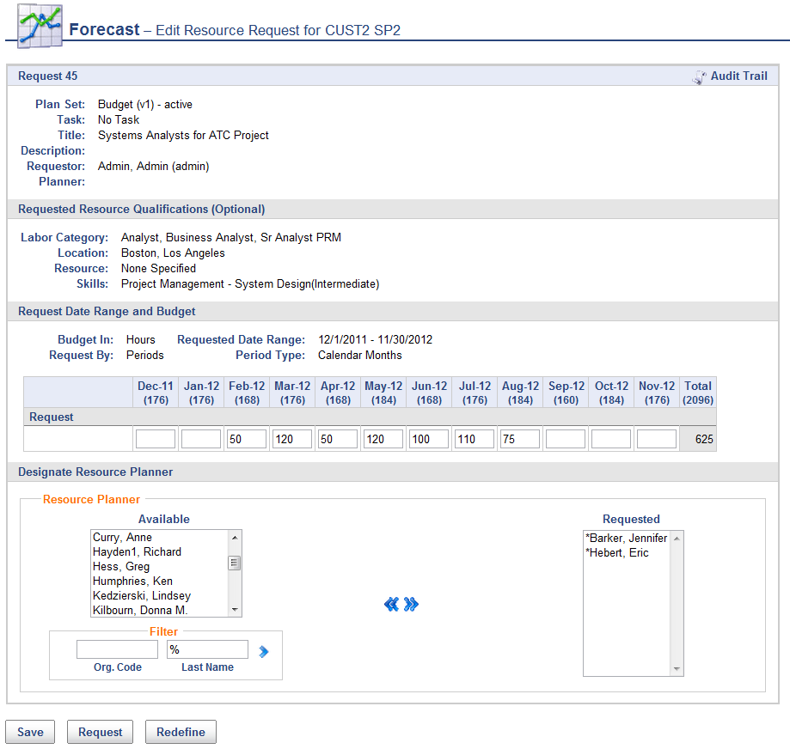

- Having completed all the relevant details the Resource Requestor will submit the request to one or more appropriate managers who will fulfill the request, known as a Resource Planner. At each stage in the process of defining and fulfilling these resource requests, relevant stakeholders can be notified via e-mail. Information on request status is also available via reports and ‘widgets’ that are displayed on relevant managers dashboards, providing one click access to resource requests that require action.

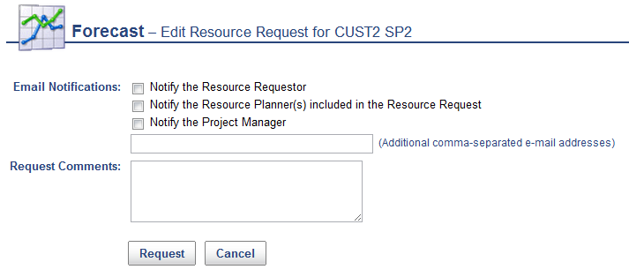

- A Resource Planner, notified of action required using one of these mechanisms, can fulfill this request with a plan at the same level of detail. The first Resource Planner to edit the Request will be identified as the responsible Resource Planner and the request will no longer be available for fulfillment by other Resource Planners. When selecting suitable resources, the Resource Planner can use the criteria specified by the Resource Requestor to search for suitable people, taking into account capacity too. A single individual or multiple people can be planned to fulfill the request. The search for suitable resources will return a screen such as the one below identifying people who fit the requirement, and also highlighting their availability by period using color coded thresholds specified by the user:

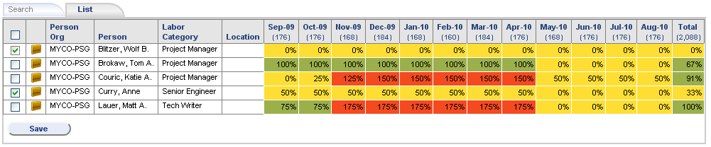

- The Resource Planner, using this information can select appropriate people, search for others using other criteria, or if there is no capacity to fulfill the request, notify the Resource Requestor. One or many people may be used to fulfill the request.

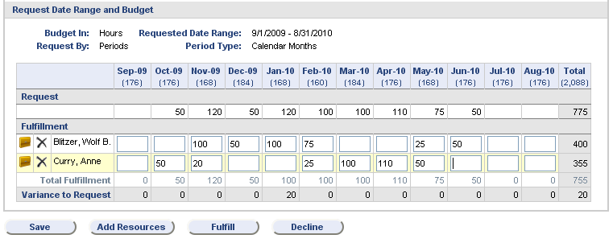

- Note in the screen above that Unanet calculates and displays the total fulfillment of resource against the request for each period, and any remaining variance that still needs to be fulfilled.

- When the request has been staffed with appropriate people, the Resource Planner selects the ‘Fulfill’ button which notifies the Resource Requestor (and optionally other stakeholders) that the staffed request is ready for review. The Resource Requestor can ‘accept’ the staffing, or return the request for Rework.

- Multiple requests can be created in this way to ensure current and future projects are adequately resourced. Once resources have been planned on a project, (often at a relatively high level) typically a project management role will create more detailed assignments for the individual against a detailed project Work Breakdown Structure.

The remainder of this document provides additional information on Unanet features which support this collaborative resource requesting and fulfillment process.

Visibility of Resource Requests and their Status
To ensure visibility of resource requests requiring action Unanet provides e-mail notifications to relevant stakeholders, and reports which allow users to see just those requests of interest based on request status, project, requestor, planner or many other criteria. Unanet also provides notification of request status using ‘widgets’ which appear on relevant users dashboards like the example below.

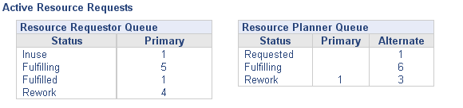

Resource Request Statuses
As staffing requirements and their fulfillment changes, a request allows the history of changes to the request to be retained. If resources need to be reassigned in the future, the history of why those individuals were assigned will enable the best-fit replacements to be quickly found. While the resource request is primarily a communication and collaboration mechanism, the structure of predefined statuses provides automation and ease-of-use. The following request statuses are defined:

- In Use –the Resource Requestor is defining it or has saved it
- Requested – when Resource Requestor has submitted – a request can be pulled back from this state
- Fulfilling – when open or modified by a Resource Planner; the Requestor cannot pull back a request from this state
- Fulfilled –resources have been planned against the request and the Resource Planner considers it fulfilled.
- Unfulfilled – the Resource Planner cannot fulfill the request and returns it to control of Resource Requestor, either for revision and resubmit to Requested for this Resource Planner or another. If there are multiple Resource Planners identified for the request, all must Decline to fulfill the request before the status reaches Unfulfilled.
- Accepted – the Requestor changes status to indicate that the planned resources are acceptable. This removes it from the widgets as an item requiring action.
- Rework – the Resource Requestor returns the request to the Resource Planner queue, providing annotation why.
- Requests that are in Accepted Status can be edited and saved by either the Resource Requestor or Resource Planner without a change in status. The system records the date/time/user who updated. A request can optionally be returned to Rework by a Resource Requestor for modification and re-fulfillment by the Resource Planner should they need to assign a different resource.

Reporting
Unanet provides reports to compare Request data with plans, and plans with capacity, as shown in the examples below. The request status report shows fulfillment of the request on a periodic basis, highlighting variances in what was requested and what has been fulfilled. Requests can also be reported on via Unanet’s flexible My Lists feature where saved criteria provide one-click access to view or edit relevant requests.

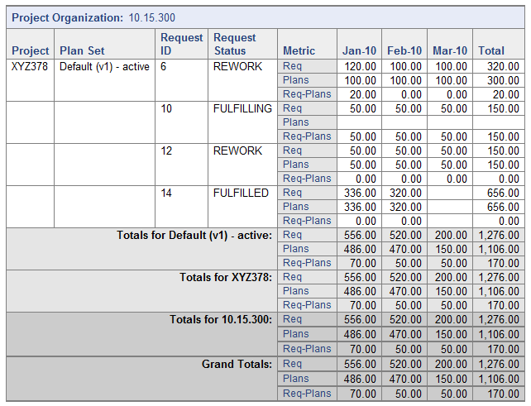

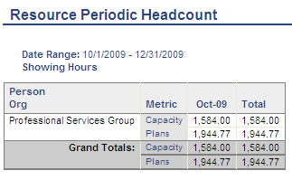
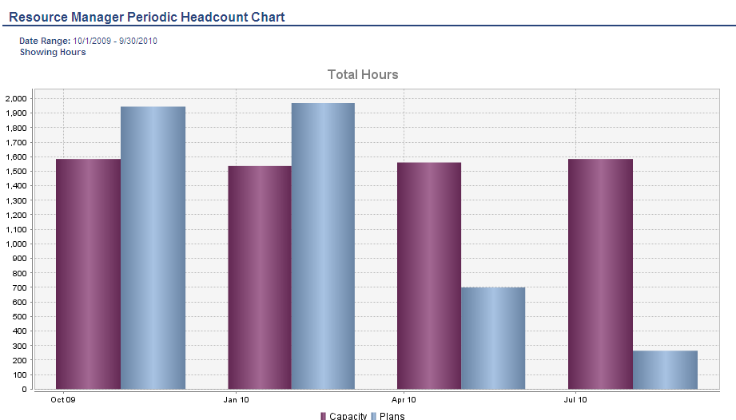

Summary
Unanet provides real-time visibility across the enterprise of resource requirements, and the capacity and capabilities of people available to fulfill those requirements. A robust set of web-based software tools and reporting features enable project and functional roles to optimize the process of identifying and staffing their current and future project labor needs. This ensures effective project startup, and adequate resourcing over the life of the project.

